**Business Question and Visualization Report**

|  |  |
| --- | --- |
| Date | 23 June 2025 |
| Project Name | Power BI Inflation Analysis – Journeying Through Global Economic Terrain |
| Maximum Marks | 5 Marks |

Visualization development refers to the process of creating graphical representations of data to facilitate understanding, analysis, and decision-making. The goal is to transform complex datasets into visual formats that are easy to interpret, enabling users to gain insights and make informed decisions. Visualization development involves selecting appropriate visual elements, designing layouts, and using interactive features to enhance the user experience. This process is commonly associated with data visualization tools and platforms, and it plays a crucial role in business intelligence, analytics, and reporting.

**Business Questions and Visualisation**

The process involves defining specific business questions to guide the creation of meaningful and actionable visualizations in Power BI. Well-framed questions help in identifying key metrics, selecting relevant data, and building visualisation that provide insights.

**Complete Business Questions and Visualizations - Global Energy Trends**

1. **What is the average global inflation rate?**

* *Visualization*: KPI Card showing Average Inflation Rate
* *Screenshot of visualisation*

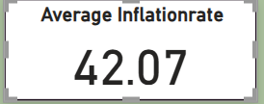

2. **Which country recorded the maximum inflation rate?**

* *Visualization*: KPI Card showing Maximum Inflation Rate
* *Screenshot of visualisation*

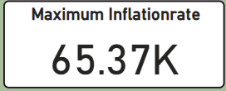

3. **How does inflation vary by inflation rate category (High, Moderate, Low)?**

* *Visualization*:Donut Chart – Sum of Inflation Rate by InflationRateCategory
* *Screenshot of visualisation*

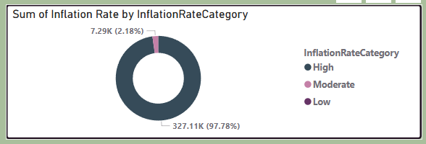

4. **What is the trend of total and adjusted inflation rate over the years?**

* *Visualization*: Column Chart – Sum of Inflation Rate and Adjusted Inflation Rate by Year
* *Screenshot of visualisation*

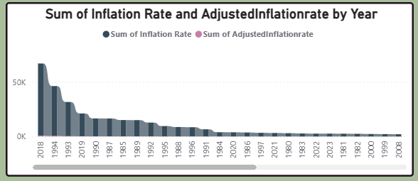

5. **Which countries show the highest adjusted inflation rates?**

* *Visualization*: Bar Chart – Adjusted Inflation Rate by Country Name
* *Screenshot of visualisation*

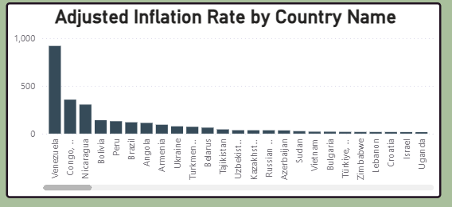

6. **How can users interactively filter inflation data by region and country?**

* *Visualization*: Region Slicer Buttons and Country Dropdown
* *Screenshot of visualisation*

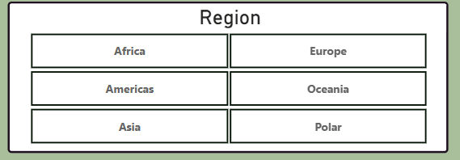

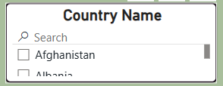

7. **How does inflation vary across different regions over time?**

* *Visualization*: Region-based filtering enables temporal comparisons across continents
* *Screenshot of visualisation*

8. **How is inflation distributed among all countries in recent years?**

* *Visualization*: Bar and Donut Charts enable exploration by inflation magnitude and category
* *Screenshot of visualisation*